[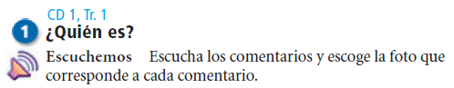](../../../03%20Spanish%20III%20Books/Expresate%20CD's,%20Video,%20Audios%203/Audios/Holt/Exprésate%20Level%203%20Disk%201/Exprésate%20Level%203%20Tr.01%20Actividad%201.mp3)

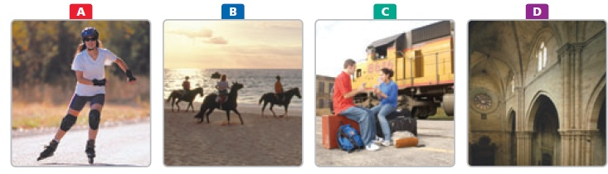

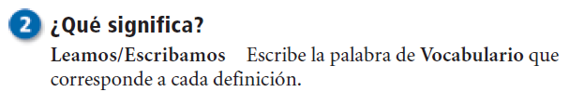

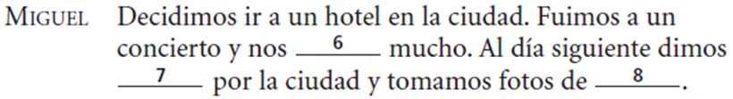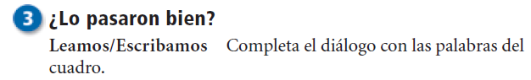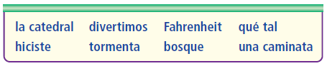

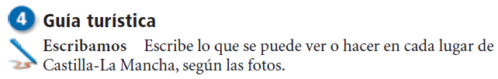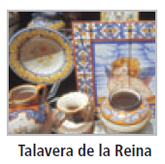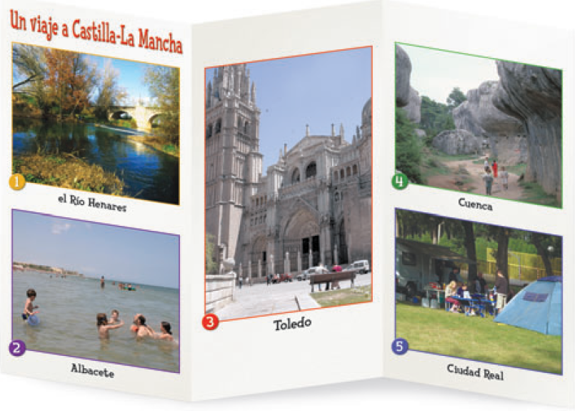

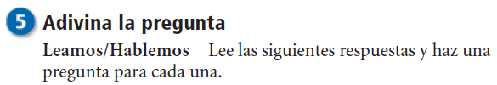

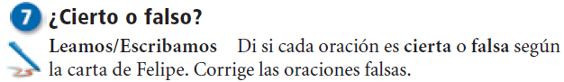

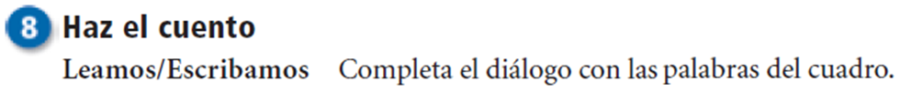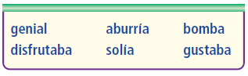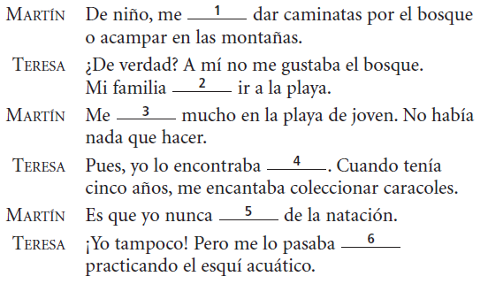

[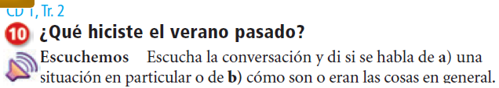](../../../03%20Spanish%20III%20Books/Expresate%20CD's,%20Video,%20Audios%203/Audios/Holt/Exprésate%20Level%203%20Disk%201/Exprésate%20Level%203%20Tr.02%20Actividad%2010.mp3)

1.

2.

3.

4.

5.

6.

7.

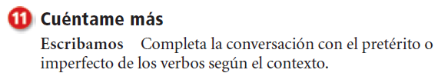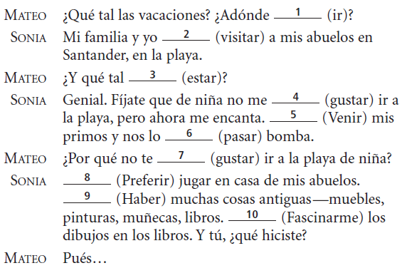

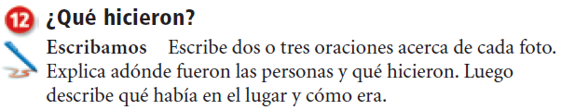





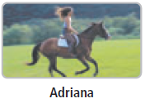

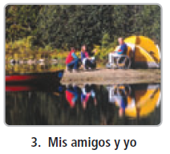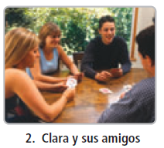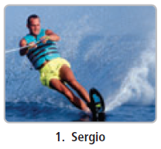

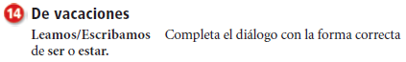

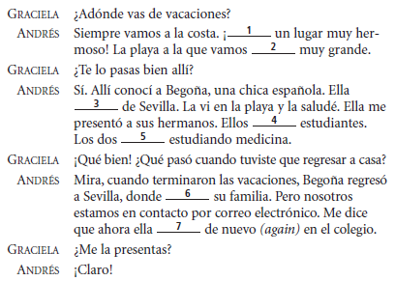

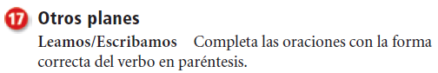

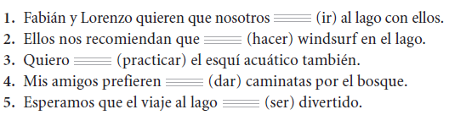

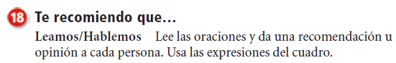

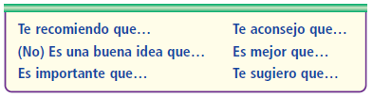

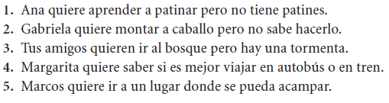

[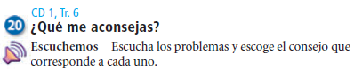](../../../03%20Spanish%20III%20Books/Expresate%20CD's,%20Video,%20Audios%203/Audios/Holt/Exprésate%20Level%203%20Disk%201/Exprésate%20Level%203%20Tr.06%20Actividad%2020.mp3)

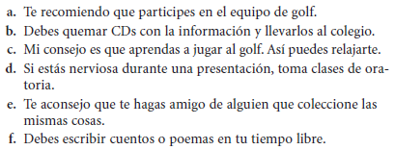

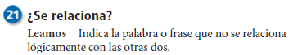

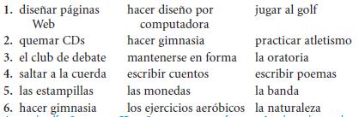

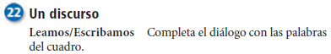



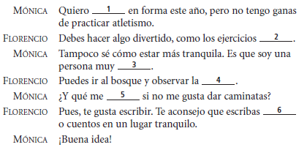

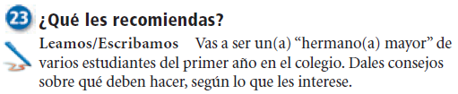





















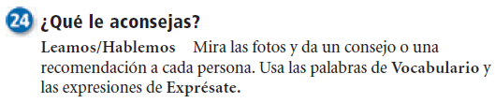

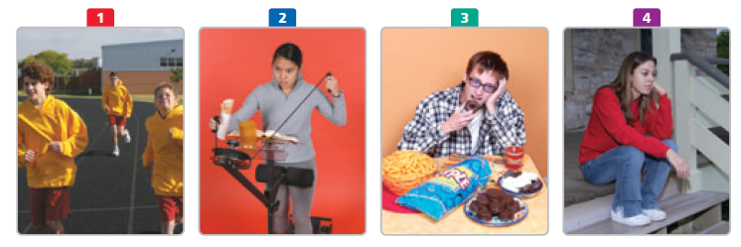

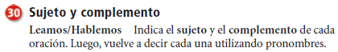















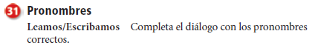

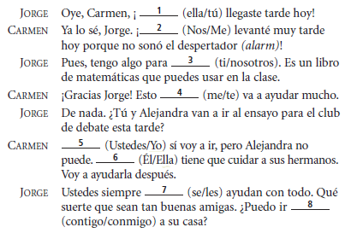

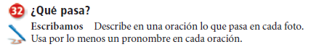

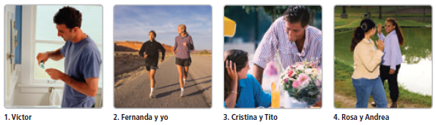

[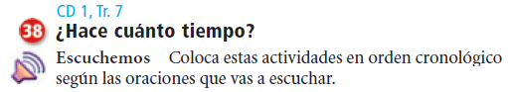](../../../03%20Spanish%20III%20Books/Expresate%20CD's,%20Video,%20Audios%203/Audios/Holt/Exprésate%20Level%203%20Disk%201/Exprésate%20Level%203%20Tr.07%20Actividad%2038.mp3)

